Betrayal Online Configuration Management Plan

**By Nobody (Team 3)  
April 11, 2024**

# [Table of Content]

1. **Introduction**
   1. **Purpose**
   2. **Scope**
   3. **Key Terms**
   4. **References**
2. **SCM Management**
   1. **Organization**
   2. **Responsibilities**
   3. **Applicable Policies, Directives, and Procedure**
3. **SCM Activities**
   1. **Configuration Identification**
   2. **Configuration Control**
   3. **Configuration Status Accounting**
   4. **Configuration Evaluation and Reviews**
   5. **Interface Control**
   6. **Subcontractor/Vendor Control**
   7. **Release Management and Delivery**
4. **SCM Schedules**
   1. **Sequence and coordination of SCM activities**
   2. **Relationship of key SCM activities to project milestones**
   3. **Schedule relative to SCM**
   4. **Graphical representation**
5. **SCM Resources**
   1. **Identifies environment, infrastructure, software tools**
   2. **Key factors for infrastructure**
   3. **Identify tools used**
6. **SCM Plan Maintenance**
   1. **Who is responsible for monitoring the plan?**
   2. **How frequently are updates to be performed?**
   3. **How changes to the Plan are to be evaluated and approved?**
   4. **How changes to the Plan are to be made and communicated?**
   5. **History of changes made to the plan.**

# Introduction

This Configuration Management Plan outlines the policies, processes, and tools that will be used to manage and track changes to the software development project. This plan has been altered to suit the needs of our specific product, and as such, some subsections may not be applicable.

* 1. **Purpose**

This Configuration Management Plan (CMP) provides a framework for the management of the configuration items (CIs) within the Betrayal: Online application. The CMP outlines the procedures, policies, and responsibilities for configuration identification, control, status accounting, evaluation and review, interface control, release management and delivery.

* 1. **Scope**

This Configuration Management Plan is applicable to all configuration items within the Betrayal: Online application. This includes product software, testing software, documentation, and any other items deemed necessary for the SCM activities.

* 1. **Key Terms**
* **Configuration Item(CI):** Any software artifacts to which the SCM is to be applied
* **Version:** A unique instance of a configuration item
* **Version Control:** A process in which all versions of systems and components are properly identified and documented. Different versions of the same component can be identified in this manner.
* **Baseline:** A formally reviewed product that serves as the as the baseline for future development. It is both a milestone and a reference point.
* **Mainline:** The sequence of baselines representing different versions of the system as a whole.
  1. **References**
* Software Engineering- Ian Sommerville- 10th edition Ch 25 pg 731-753 (Configuration management)

# SCM Management

* 1. **Organization**
* The Nobody project team will be responsible for the implementation of the SCM activities laid out in this document. A team member will provide guidance and support for all SCM activities.
* All of the Project Management, Configuration Management, and Development Team tasks will be handled together with our whole team at the forefront of said tasks. Our team is cohesive and works together to accomplish the tasks at hand.
  1. **Responsibilities**
* **Development Team**:
  + Purpose and Objectives: Responsible for identifying and documenting Configuration Items (CIs), QA testing, controlling changes to CIs, and ensuring compliance with the CMP.
  + Membership and Affiliations: team members.
  + Scope of Authority: Implementation of development tasks.
  + Operational Procedures: Participate in CI identification, testing, and change control processes.
  + Period of Effectivity: Throughout the project lifecycle.
  + Purpose and Objectives: Responsible for overall project management and ensuring that SCM activities are conducted per the CMP.
  + Membership and Affiliations: Project leadership.
  1. **Applicable Policies, Directives, and Procedures**
* Our team has chosen to omit this section as it does not apply to our project.

# SCM Activities

* 1. **Configuration Identification**

* + 1. Configuration Items: Betrayal: Online (1.0.0), betrayal.py, requirements.txt, docker_cli.txt, docker_shell.sh
    2. The Betrayal: Online app will launch in version 1.0.0.
    3. Configuration items will be available for acquisition through the Nobody Team Github. Team members will do work in individual branches before merging them into the main branch. Changes will be tracked in the team repository.
  1. **Configuration Control**
     1. Change requests will be submitted through a change request form. This change request will be sent to a team member, who will distribute the work to another team member or take on the responsibility.
     2. Changes will be verified and validated by the other team members.
     3. Approving or disapproving changes will be implemented by a team member.
     4. Baselines will be established at significant release milestones through input of the entire team.
  2. **Configuration Status Accounting**
     1. All configuration status accounting will be done through the Nobody GitHub repository. All commits and changes will be tracked and reported to a team member.
     2. Access to any data related to configuration status accounting will be viewable and traceable within the repository.
  3. **Configuration Evaluation and Reviews**
     1. An audit on a CI will take place prior to the a major release of the Betrayal: Online application.
     2. Audits will be conducted and processed by team members before a major release, with the result of the audit being stored in the software management system.
  4. **Interface Control**
     1. The team will coordinate changes to CI interfacing items outside of the scope of the plan on an as-needed basis/
  5. **Subcontractor/Vendor Control**
     1. Docker Desktop developed by Docker, inc.
  6. **Release Management and Delivery**
     1. The product’s release build will be created through Docker by a team member.

# SCM Schedules

* 1. **Sequence and coordination of SCM activities**
* Coordination of SCM activities will be handled by the Nobody team as activities are assigned to ourselves via jira board.
  1. **Relationship of key SCM activities to project milestones:**
* After initial launch the configuration baseline is established whenever a team member merges all branches into the main branch. Then to be packaged and released.
* Implementation of change control procedures will be handled by a team member.
* Once a configuration audit is deemed necessary and assigned by a team member, it should be completed within the time between deliverables
  1. **Schedule**
* SCM activities will be scheduled every 1-2 weeks after the initial baseline is released.
* SCM activities will be updated on this basis as well where the development will proceed following this schedule.
* Once a running phase of the game is up other implementations will be involved in making the game more fleshed out allowing us to expand our system more.
  1. **Graphical representation**

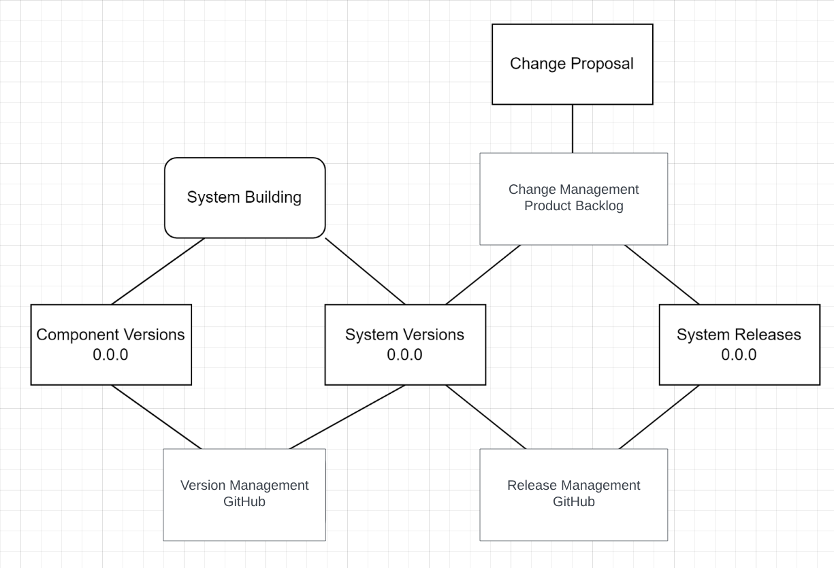

# SCM Resources

* 1. **Identifies environment, infrastructure, software tools, techniques, equipment, personnel, and training.**
* All change management will be conducted through Git, Python will be used for the backend of the application, Docker will be used to containerize the application. Jira will be used as agile project management software. All team members will be trained to use these tools in the development of Betrayal: Online.
  1. **Key factors for infrastructure:**
* The system will use a local database to store information about the game. At release, the application will support local multiplayer through Local Area Network (LAN).
* *Dependencies*: python==3.12, pgzero==1.2.1, unittest, sqlite3
  1. **Identify which tools are used in which activity.**
* GitHub(Distributed Control Management System/Release)
* Python(Backend)
* SQLite3 (Local Database)

# SCM Plan Maintenance

* 1. **Who is responsible for monitoring the plan?**
* The team will keep each other accountable and on track to make sure that we are able to stick to the plan
  1. **How frequently updates are to be performed?**
* Updates will be performed every 1-2 weeks or as required.
  1. **How changes to the Plan are to be evaluated and approved?**
* Changes to this plan will be communicated and corroborated between team members such that we all stay on the same page and are able to be up to date with each other.
  1. **How changes to the Plan are to be made and communicated?**
* Any changes made to the plan will be communicated to the necessary parties by email, updating documentation stored in the configuration management software, as well as, notifying team members on the project Discord.
  1. **History of changes made to the plan.**
* No changes have been made to this plan as of April 11, 2024.

| Changes | Date | Initials |
| --- | --- | --- |
| Initial Plan Created(0.1) | 4/11/24 | EW |
|  |  |  |
|  |  |  |
|  |  |  |
|  |  |  |
|  |  |  |